# STOCK PRICE ANLYSIS



INTRODUCTION

Amazon.com, Inc., commonly known as Amazon, is an American multinational technology company founded by Jeff Bezos on July 5, 1994. It started as an online bookstore but rapidly expanded its offerings to become one of the world's largest and most influential companies. Amazon is headquartered in Seattle, Washington, and operates across various sectors, including e-commerce, cloud computing, digital streaming, artificial intelligence, and more.

Amazon's core business is its e-commerce platform, which offers a vast selection of products, ranging from electronics and apparel to groceries and household items. The company's customer-centric approach, competitive pricing, and fast delivery options, notably through its Amazon Prime subscription service, have solidified its position as a dominant force in online retail.

In addition to its e-commerce operations, Amazon is a leader in cloud computing services through its Amazon Web Services (AWS) platform. AWS provides a comprehensive suite of cloud-based computing resources, including storage, computing power, databases, machine learning, and more, to businesses and individuals worldwide.

Amazon has also expanded into digital content and services, offering streaming services such as Prime Video and Prime Music, as well as Kindle e-readers and e-books. Its hardware portfolio includes devices like the Kindle, Echo smart speakers, and Fire tablets, powered by the virtual assistant Alexa.

* GENERAL OVERVIEW :! Here's a general overview of Amazon Inc.:

Company Name: Amazon.com, Inc.

Founded: July 5, 1994

Founder: Jeff Bezos

Headquarters: Seattle, Washington, United States

CEO: Andy Jassy (as of July 2021, succeeding Jeff Bezos)

Industry: E-commerce, Cloud Computing, Digital Streaming, Artificial Intelligence, Consumer Electronics, Logistics, and more.

Overview: Amazon.com, Inc. is one of the world's largest and most influential technology companies. It started as an online bookstore but quickly diversified its offerings to become a global leader in e-commerce, cloud computing, digital streaming, artificial intelligence, and more. Amazon's success is attributed to its relentless focus on customer satisfaction, innovation, and operational excellence.

# Key Businesses:

E-commerce: Amazon operates one of the largest online marketplaces globally, offering a vast selection of products across various categories, including electronics, apparel, books, and household goods.

Amazon Web Services (AWS): AWS is Amazon's cloud computing platform, providing on-demand computing power, storage, and other services to businesses, governments, and individuals worldwide.

Digital Content and Services: Amazon offers digital content and services such as Prime Video for streaming movies and TV shows, Prime Music for streaming music, Kindle e-readers and e-books, and Audible audiobooks.

Artificial Intelligence (AI) and Machine Learning: Amazon leverages AI and machine learning technologies to enhance its customer experience, optimize operations, and develop new products and services. Examples include Alexa-powered devices and AI-driven recommendation systems.

Physical Retail: In addition to its online presence, Amazon operates physical retail stores, including Amazon Go (cashier-less convenience stores), Amazon Books (brick-and-mortar bookstores), and Whole Foods Market (acquired in 2017).

Corporate Culture:

Amazon is known for its customer-centric culture, innovation, and relentless pursuit of excellence. The company values frugality, data-driven decision-making, and a bias for action. However, it has also faced criticism and scrutiny over its labor practices, antitrust concerns, and environmental impact.

Financial Performance:

Amazon has consistently delivered strong financial performance, driven by its diverse business portfolio and continued growth in e-commerce, cloud computing, and other segments. Its market capitalization has made it one of the most valuable companies globally.

key points of amazon inc : Founding and Growth: Amazon was founded by Jeff Bezos in 1994 as an online bookstore. It quickly expanded into various product categories and became one of the world's largest e-commerce companies.

Diversified Business: Amazon has diversified its business beyond e-commerce. It offers cloud computing services (AWS), digital streaming (Amazon Prime Video, Music), hardware (Kindle, Echo), and brick-and-mortar retail (Amazon Go, Amazon Books).

Market Dominance: Amazon is a dominant force in e-commerce, accounting for a significant share of online retail sales globally. Its Prime membership program has helped drive customer loyalty and engagement.

AWS Leadership: Amazon Web Services (AWS) is a leader in the cloud computing market, providing infrastructure and services to businesses, governments, and individuals. AWS generates a significant portion of Amazon's revenue and profits.

Innovative Technologies: Amazon invests heavily in innovation, developing technologies such as drone delivery, cashier-less stores (Amazon Go), and voice-controlled assistants (Alexa) to enhance customer experience and operational efficiency.

Logistics and Fulfillment: Amazon operates an extensive logistics network, including fulfillment centers, delivery stations, and transportation services, to enable fast and reliable product delivery to customers worldwide.

Corporate Culture: Amazon is known for its demanding work culture, characterized by high performance expectations, innovation, and customer obsession. The company values frugality, data-driven decision-making, and a bias for action.

Controversies and Criticism: Amazon has faced criticism for various issues, including labor practices in its fulfillment centers, antitrust concerns related to its market power, tax practices, and environmental impact. Bezos and other Amazon executives have testified before Congress regarding these issues.

Global Expansion: Amazon has expanded its operations globally, serving customers in numerous countries and regions. It has established subsidiaries and acquired companies worldwide to strengthen its presence in key markets.

Philanthropy and Sustainability: Amazon has launched initiatives to support communities, including the Amazon Future Engineer program, which aims to increase access to computer science education for children from underserved communities. It has also committed to sustainability goals, such as the Climate Pledge to achieve net-zero carbon emissions by 2040

historical price data

|  |  |
| --- | --- |
| Previous Close | **180.97** |
| Open | **179.09** |
| Bid |  |
| Ask |  |
| Day's Range | **178.38 - 180.79** |
| 52 Week Range | **97.71 - 183.00** |
| Volume | **31,309,191** |
| Avg. Volume | **43,615,466** |
| Market Cap | **1.877T** |
| Beta (5Y Monthly) | **1.17** |
| PE Ratio (TTM) | **62.52** |
| EPS (TTM) | **2.89** |
| Earnings Date | **Apr 25, 2024 - Apr 29, 2024** |
| Forward Dividend & Yield | **N/A (N/A)** |
| Ex-Dividend Date | **N/A** |
| 1y Target Est | **208.64** |

**HISTORICAL PRICE CHRT**

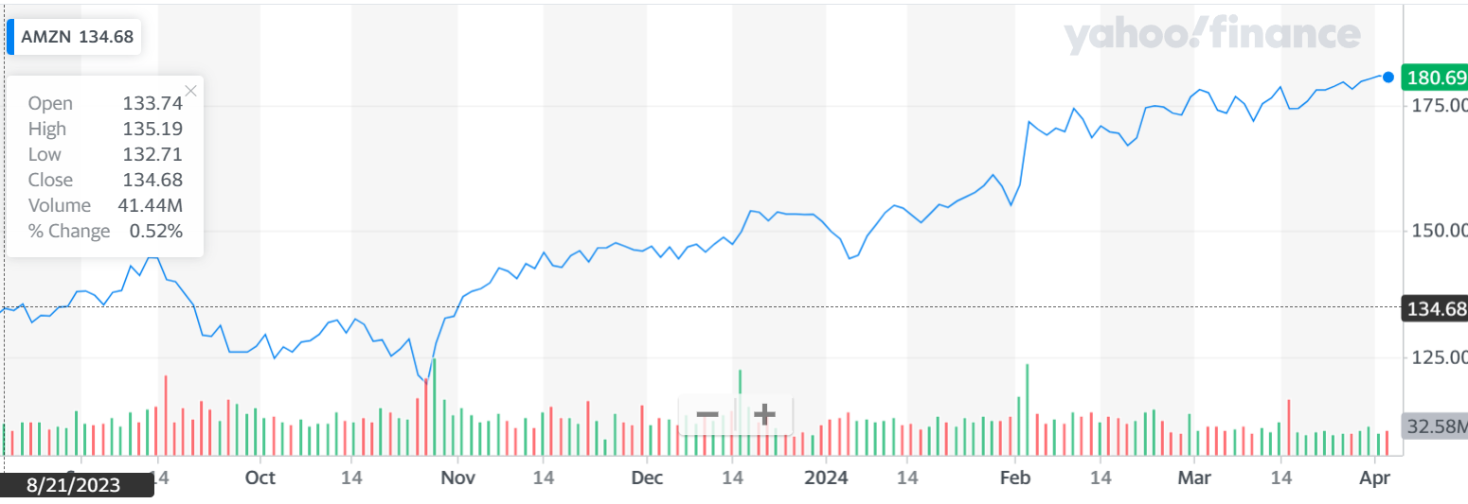

KEY MATRICS :

The company's P/E ratio was 25.93 in 2021. According to estimates, the company's P/E ratio for 2022 is expected to be 121.74 and 53.85 in 2023.5 As a standard of comparison, Apple ([AAPL](https://www.investopedia.com/markets/quote?tvwidgetsymbol=aapl)) had a price-to-earnings ratio of 21.27 in 2022. The tech giant's estimated P/E ratio for 2023 is expected to be 21.02.

* Traditional measurements of value often fail when applied to Amazon.
* The sales growth rate is a better guide to Amazon's corporate health, with 30% per year being typical.
* Amazon Web Services, the company's internet cloud infrastructure, is a primary driver for the company's sales growth.
* The operating profit margin at Amazon went up substantially between 2014 and 2019.
* Amazon's high price-to-earnings ratio does not mean the stock is going to crash, but it does make shares more volatile.

VOLATILITY

Amazon appears to be very steady, given 3 months investment horizon. Amazon Inc secures Sharpe Ratio (or Efficiency) of 0.23, which signifies that the company had a 0.23% return per unit of standard deviation over the last 3 months. We have found twenty-nine technical indicators for Amazon Inc, which you can use to evaluate the volatility of the firm. Please makes use of Amazon's mean deviation of 1.16, and Risk Adjusted Performance of 0.0978 to double-check if our risk estimates are consistent with your expectations. Key indicators related to Amazon's volatility include

* 720 Days Market Risk
* Very steady
* Chance Of Distress
* Low
* 720 Days Economic Sensitivity

**Average Trading Volume**

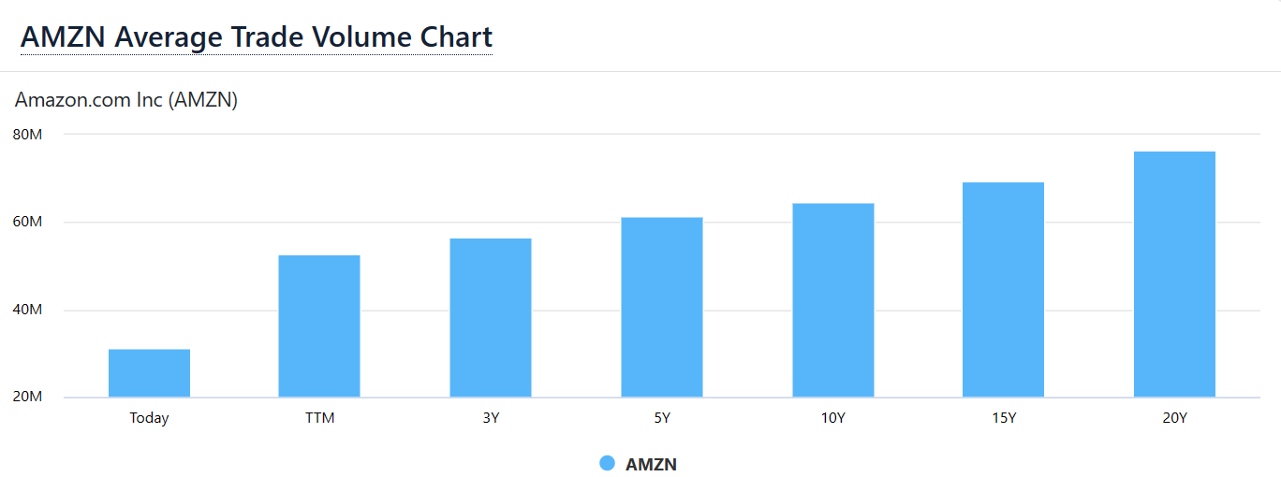

The average trade volume for **Amazon.com (AMZN)** stock is **52.739M** over the past 12 months.  
The average trading volume for Amazon.com (AMZN) stock over the past 12 months is indeed significant, indicating a high level of investor interest and activity in the stock. [This volume reflects the total number of shares traded per day on average and can be a useful indicator of liquidity and market sentiment1](https://www.financecharts.com/stocks/AMZN/summary/volume-averages). It’s important to note that trading volumes can fluctuate based on market conditions, news, and company developments. For investors, understanding these trends can be crucial for making informed trading decisions.

**STOCK COMPARSION AND ANALYSIS**

PREVIOUS CLOSE

The last closing price

$180.97

DAY RANGE

The range between the high and low prices over the past day

$178.38 - $180.79

YEAR RANGE

The range between the high and low prices over the past 52 weeks

$97.71 - $183.00

MARKET CAP

A valuation method that multiplies the price of a company's shares by the total number of outstanding shares.

1.88T USD

AVG. VOLUME

The average number of shares traded each day over the past 30 days

37.95M

P/E RATIO

The ratio of current share price to trailing 12-month EPS that signals if the price is high or low compared to other stocks

62.31

DIVIDEND YIELD

The ratio of annual dividend to current share price that estimates the dividend return of a stock

-

PRIMARY EXCHANGE

Listed exchange for this security

NASDAQ

# Trading Information

### Stock Price History

|  |  |  |
| --- | --- | --- |
| Beta (5Y Monthly) | | 1.17 |
| 52-Week Change 3 | | 78.74% |
| S&P500 52-Week Change 3 | | 27.27% |
| 52 Week High 3 | | 183.00 |
| 52 Week Low 3 | | 97.71 |
| 50-Day Moving Average 3 | | 172.35 |
| 200-Day Moving Average 3 | | 147.15 |
| Valuation Measures4  |  |  | | --- | --- | | Market Cap (intraday) | 1.88T | | Enterprise Value | 1.93T | | Trailing P/E | 62.31 | | Forward P/E | 42.73 | | PEG Ratio (5 yr expected) | 2.44 | | Price/Sales (ttm) | 3.30 | | Price/Book (mrq) | 9.30 | | Enterprise Value/Revenue | 3.35 | | Enterprise Value/EBITDA | 21.54 | | |  |

# Share Statistics

|  |  |
| --- | --- |
| Avg Vol (3 month) 3 | 43.62M |
| Avg Vol (10 day) 3 | 30.85M |
| Shares Outstanding 5 | 10.39B |
| Implied Shares Outstanding 6 | 10.39B |
| Float 8 | 9.22B |
| % Held by Insiders 1 | 9.18% |
| % Held by Institutions 1 | 62.83% |
| Shares Short (Mar 15, 2024) 4 | 72.82M |
| Short Ratio (Mar 15, 2024) 4 | 1.74 |
| Short % of Float (Mar 15, 2024) 4 | 0.93% |
| Short % of Shares Outstanding (Mar 15, 2024) 4 | 0.70% |
| Shares Short (prior month Feb 15, 2024) 4 | 67.06M |
| Income Statement  |  |  | | --- | --- | | Revenue (ttm) | 574.78B | | Revenue Per Share (ttm) | 55.78 | | Quarterly Revenue Growth (yoy) | 13.90% | | Gross Profit (ttm) | N/A | | EBITDA | 85.52B | | Net Income Avi to Common (ttm) | 30.42B | | Diluted EPS (ttm) | 2.89 | | Quarterly Earnings Growth (yoy) | 3,721.60% | |  |

**ANALYSIS**

**Earnings Reports: Quarterly earnings reports often have a significant impact on a company's stock price. If Amazon's earnings exceed or fall short of analysts' expectations, it can lead to corresponding movements in the stock price.**

**Product Launches and Innovations: The introduction of new products or services, such as updates to Amazon Web Services (AWS), new features on the Amazon platform, or expansions into new markets, can influence investor sentiment and impact the stock price.**

**Regulatory Issues: Amazon has faced scrutiny from regulators in various jurisdictions regarding its market dominance, labor practices, and antitrust concerns. Any developments related to regulatory investigations or legal battles could affect investor confidence and stock performance.**

**Macroeconomic Factors: Economic indicators, such as changes in consumer spending, interest rates, or overall market trends, can impact Amazon's stock price along with the broader market.**

**Competitor News: Developments related to Amazon's competitors, such as Walmart, Alibaba, or other e-commerce giants, could affect investor perceptions of Amazon's competitive position and influence the stock price.**

**Pandemic-related Impacts: The ongoing COVID-19 pandemic has affected various aspects of Amazon's business, including changes in consumer behavior, supply chain disruptions, and shifts in demand for e-commerce services. Any updates on how Amazon is navigating these challenges could influence the stock price.**

**Leadership Changes: Changes in executive leadership or key personnel within Amazon could lead to speculation about the company's future direction and impact investor sentiment.**